How to Install and Configure the Xerox Print Driver
- Download the Xerox drivers from the server. http://it.clas.ufl.edu/howto/shared-drives-mac/
From the folder “Xerox Print Drivers”.
Use “10-6-8-XeroxPrintDriver.2.112.0” for 10.6.8 and “XeroxPrintDriver.3.13.0-1282” for 10.7-10.9
The driver is for both the Mailroom and Grad lounge printers.
- Install the driver
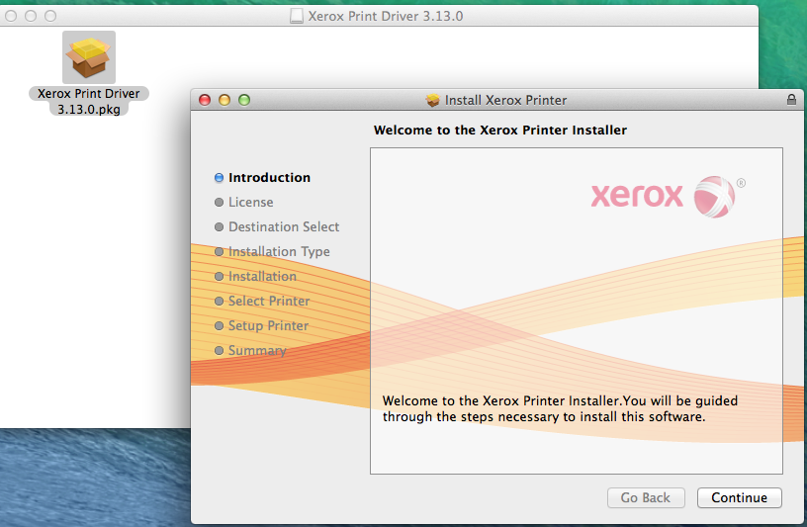

- When prompted to Select a Printer click Continue.
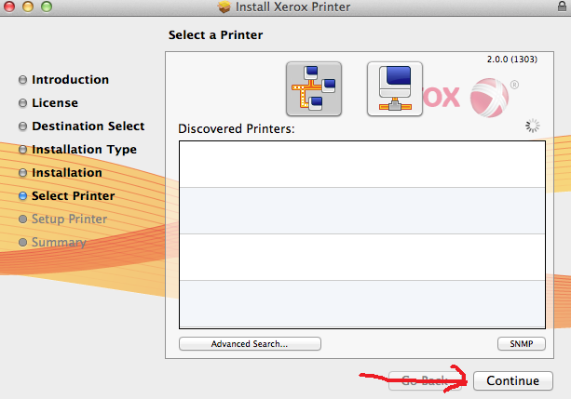

- Click Continue again.
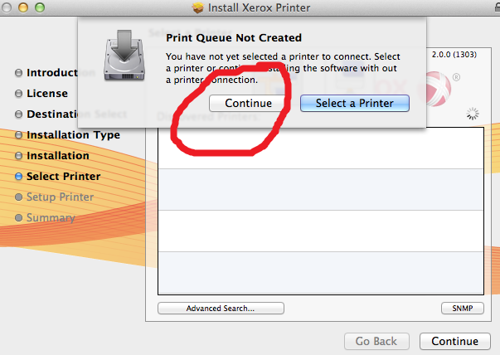

- Finish
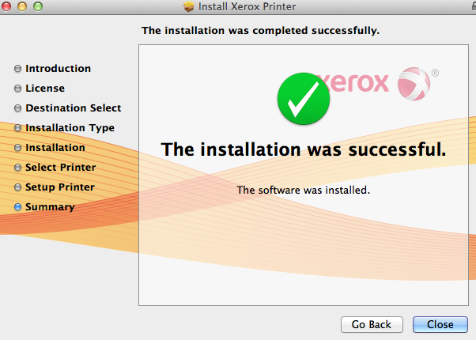

Then install the printer using these directions:
http://it.clas.ufl.edu/howto/network-printer-mac/
The printer names are: bar-228-2 (color), bar-324-1, bar-425-1, bar-525-1, bar-628-1 (color)

- Once the printer is installed open Safari, click the File drop down menu and click Print. 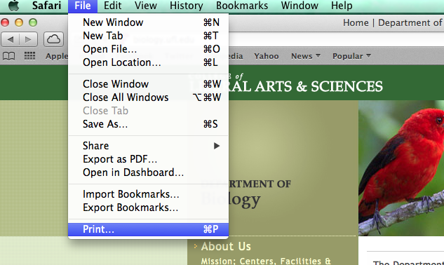
- The Printer Configuration interface will open. Make sure that the Mailroom or Grad Lounge printer is selected. Click Show Details if necessary.
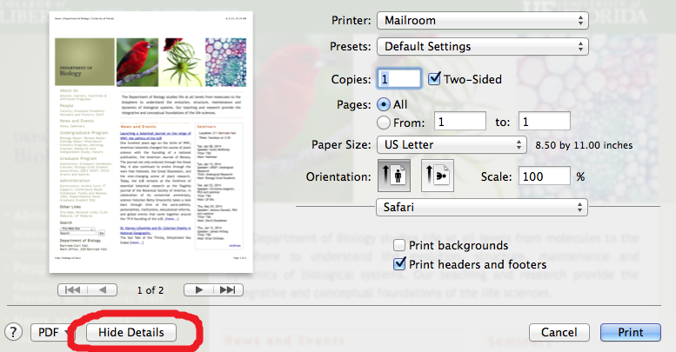
- Below the selected printer you will see the application you are using, Safari in this case. Click the drop down list next to the application listed. Several options will be listed in the drop down list, click Xerox Features.
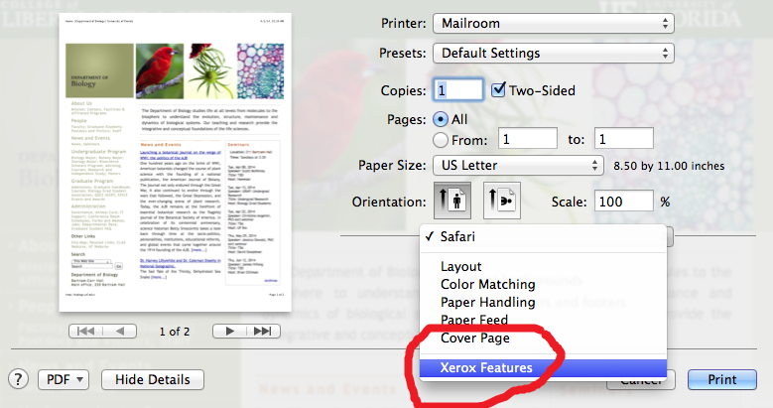

- The Xerox Features interface will open, select 2-Sided Print, then click the arrows next to Paper/Output and click Advanced.
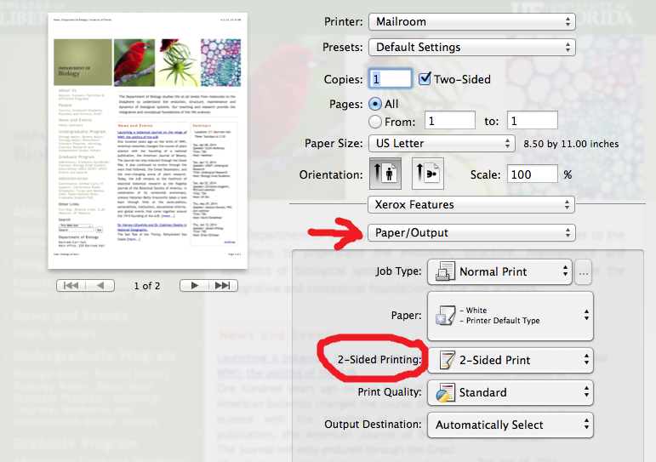

- Select the Color Options.
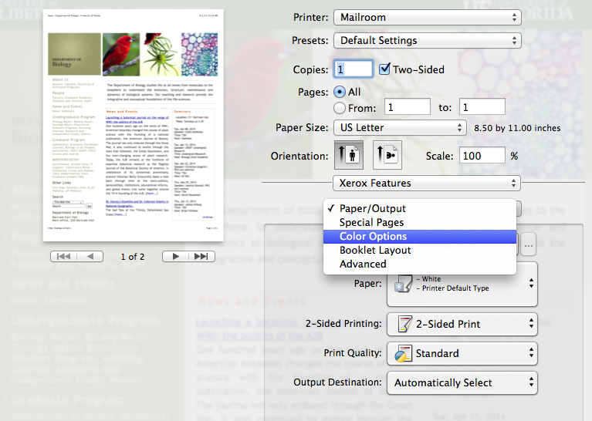
- Select Black and White. 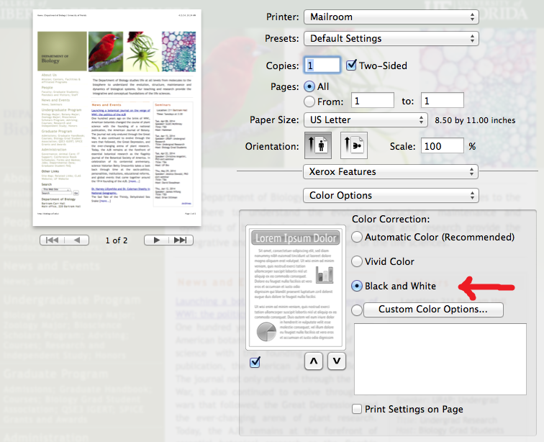

- From the Presets menu select Save Current Settings as Preset.
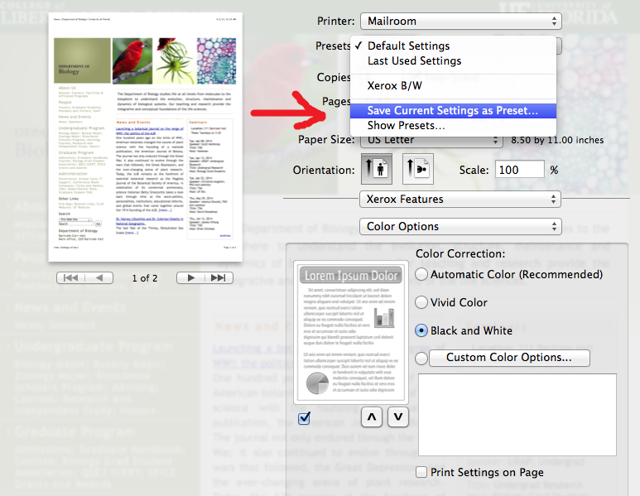

- Name it something like Mailroom Duplex / Black and white.
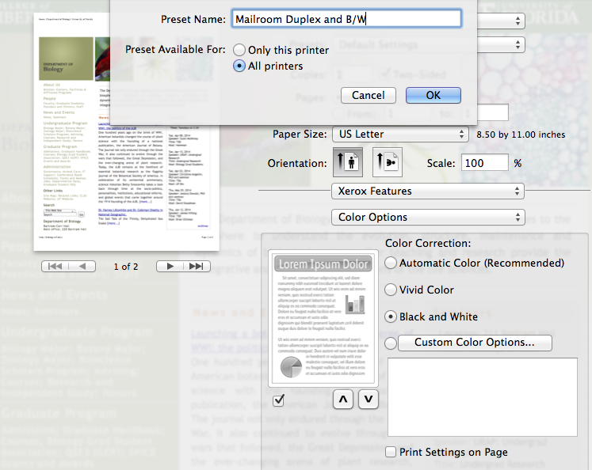

- Click OK. The next time you print something use that preset.
