BSC 2010 – Integrated Principles of Biology I
Syllabus for 7252
Summer 2014

Class Meetings
Tuesday, Wednesday, Thursday, Friday
Section 7252 Period Summer 1 8:00 AM–9:15 AM Physics Building 1001 (NPB 1001)

Online Exercises and Tutorials are continuously available; particular assignments will be posted regularly.

BSC Laboratory Courses
The BSC laboratory courses (BSC 2010L and BSC 2011L) are managed separately from the BSC lecture courses. Please read the information available at the BSC Website (http://www.bsc.ufl.edu) for more information on the laboratory courses.

Instructors
Dr. Stuart McDaniel, PhD
Department of Biology
Office: 213 Carr Hall
Office Hours: Immediately following class or by appointment
Email: stuartmcdaniel@ufl.edu

Katrina Cuddy (Discussion Leader and Online Instructor)
Graduate Teaching Assistant
Department of Biology
Office: 310 Bartram Hall
Office Hours: Thursday 5:30PM – 6:20PM or by appointment (please email)
Email: kkcuddy@ufl.edu

Expectations
Each student is solely responsible for reading and following the instructions, guidelines and schedules in this syllabus. Not having read the information in this syllabus will not constitute an excuse for missing an assignment, exam, or other assessment.

Email Communication
All email correspondence to course instructors must originate from your ufl.edu account, have your full name in the body of the email, and contain your course and section number in the subject line. Emails not meeting these requirements may not be recognized by our email filters, and thus may not be answered.
All correspondence regarding the online assignments (BioPortal) must be sent to the Online Instructor (Ms. Katrina Cuddy).

Course Resources


Textbook
Principles of Life, by Hillis, Sadava, Heller, & Price, Sinauer Associates and W.H. Freeman (publisher)
Textbook publisher web site: http://courses.bfwpub.com/hillis1e.php.
There are current versions of the textbook on reserve at the Marston Science Library. Visit the Reserve Materials area to check out these copies.

Online Resources and Electronic Textbook
BioPortal is an online assignments and tutorial system from the textbook publisher. It is required for this course and includes an e-book with purchase. Each new copy of the Principles of Life textbook comes automatically packaged with BioPortal and an e-book. Alternatively, you may access BioPortal and the e-book by making a standalone purchase either online at http://courses.bfwpub.com/hillis1e.php

The BioPortal website is: http://courses.bfwpub.com/hillis1e.php. When setting up your account, you must use your Gatorlink (ufl.edu) email address, which will be your username. Using an email address other than your UFL email address will result in receive NO credit for all assignments administrated through BioPortal. This cannot be changed after registration, thus be sure to register correctly.
For help with BioPortal, contact BioPortal Technical Support: 1-800-936-6899 (phone) or techsupport@bfwpub.com (email).

Classroom Response System (Clicker)

We will use the Top Hat Monocle (THM) Classroom Response System (CRS) for quiz questions during class. THM allows students to use a cell phone (text messaging), laptop, smartphone, or an iPod touch to participate in class. To register, follow these instructions:
- Go to https://www.tophatmonocle.com/register/
- Click “Continue” under “Student”

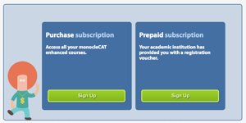
- Click “Sign Up” under “Purchase subscription”.
If you purchased a license key from the bookstore, click “Sign Up” under “Prepaid Subscription”.

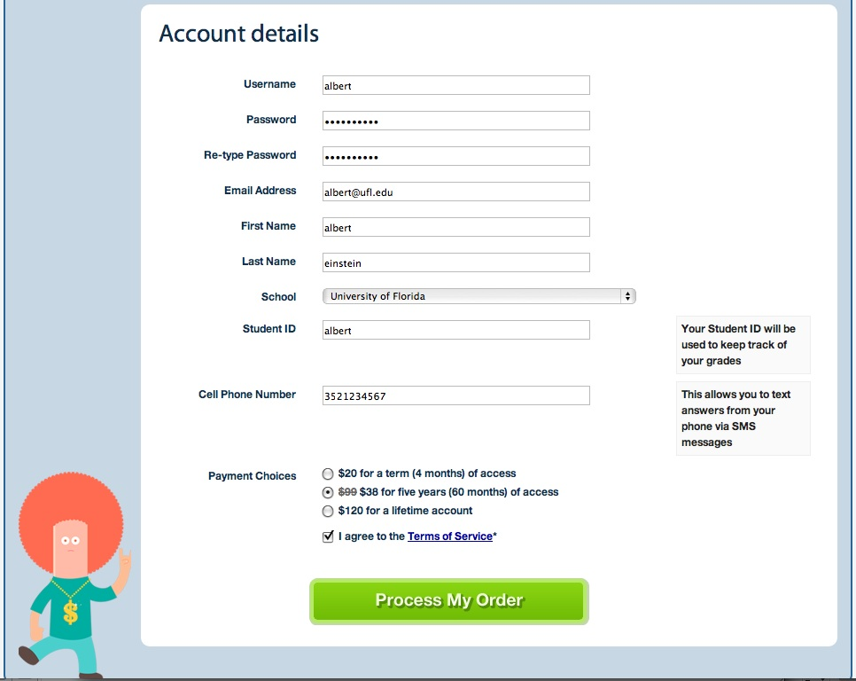

- Fill in all account details:
You must use your Gatorlink ID for your “Username” and your “Student ID”
Example: If your email address is albert@ufl.edu, use albert NOT your 8-digit numerical UF ID (e.g., 1234-5678).
If the “Username” is already taken, you may add a few numbers to the end (e.g., albert123). Your “Student ID” must be your Gatorlink ID however.
For “School” choose “University of Florida”.
We recommend that you choose the $38 option for five years of access (see explanation below).
- Click “Process My Order”.

Note that THM will be used in BSC 2011 and in other upper division courses offered through the Biology Department. Thus, it is advantageous to purchase the 5-year subscription rather than a single semester subscription.

Important note about purchasing THM license keys (prepaid subscriptions) at the bookstore:
You can purchase prepaid subscriptions for THM at the UF Bookstore. A 5-year subscription will cost $50.75 (instead of $38.00 if purchased from the THM website) and a 4-month (semester) subscription will cost $26.75 (instead of $20.00 if purchased from the THM website). However, purchasing the THM subscription at the bookstore may benefit those students with financial aid.
For problems with Top Hat Monocle, call the following support number: 1-888-663-5491 or email support@tophatmonocle.com
Additional Top Hat Monocle information is posted on the e-Learning website under “Resources”.

Course Website (e-Learning)
Class material including the syllabus, discussion readings and problem sets, exam results, some lecture slides and other information related to the course will be posted on the course e-Learning website (http://lss.at.ufl.edu). You are responsible for all announcements made in lecture and/or posted on the course website for this class. For help with e-Learning, call the UF Computing Help Desk at 352-392-4357, or visit the e-Learning support website: https://lss.at.ufl.edu/help.shtml.

Online Instruction Information
Online Instructor: Katrina Cuddy
Email address: kkcuddy@ufl.edu
Office: 310 Bartram Hall
Office hours: Thursday 5:30PM – 6:20PM or by appointment (please email if you plan to come to office hours)

As part of BSC 2010, you are required to complete online assignments that will account for 12% of your overall grade. If at any time you have questions about these assignments, please contact the Online Instructor (Ms. Katrina Cuddy). DO NOT contact the Lecturer for questions about online homework completed through BioPortal. Online assignments will be completed online at the BioPortal website: (http://courses.bfwpub.com/hillis1e.php; see instructions posted on e-Learning on how to access website). A schedule will be posted on e-Learning with the due dates for each assignment. All assignments must be completed by the stated due date and time for credit. Extensions will NOT be given because of technical or personal issues that occur within 24 hours of the assignment deadline. Most assignments will also have a set time limit, so make sure you have time to devote to that assignment before you begin. You are expected to work by yourself on the assignments and cheating will not be tolerated.
Note that all due dates for assignments are clearly posted on the BioPortal Assignments tab and reflect the most up-to-date information. On this page you can also see your grade on an assignment and its status (e.g., complete, or due in x days). Also, there are many other resources available on BioPortal to help you study material from your textbook, such as Diagnostic quizzes, Flashcards, Interactive chapter summaries, etc. Items that are NOT on the assignments page will not be graded, but we still encourage you to use them to help you study.
If you have technical difficulties, please contact BioPortal Technical Support: 1-800-936-6899 (phone) or techsupport@bfwpub.com (e-mail).

To facilitate discussion, a discussion forum will set up in e-Learning / Sakai. Any questions regarding the lecture material or the online assignments should be posted there, so that your fellow students will be able to provide answers. Don’t be shy about asking questions; after all, if you are confused about the material there will almost certainly be other students with the same questions.

Communication with Your Online Instructor
When you have a question about the BioPortal assignments, check the following sources first to see if it is already answered, before e-mailing your Online Instructor:
- Course Syllabus
- e-Learning announcements (this is the primary means that your Online Instructor has to communicate with you in a timely manner)
- e-Learning Discussion FAQ
- e-Learning Discussion General Posts
If you still cannot find the answer to your questions:
- If it is a question that others might find useful to know the answer to as well, post it in the e-Learning Discussion section.
- If it is a question specific to you (e.g. account or grade specific), e-mail Ms. Cuddy. Barring unusual circumstances, expect a reply with 24 hours. E-mails and e-Learning Discussion posts are checked at least once per day, but sometimes not more than that.
If there is a technical problem with accessing BioPortal or a particular assignment within BioPortal, you must contact BioPortal technical support FIRST. BioPortal tech support is the only one who can fix technical issues with the site. Then contact the Online Instructor at least 48 hours prior to the deadline, so appropriate steps can be taken to fix the issue and appropriate extensions can be given if necessary. (Thus, check early that you can access the assignments. You will not be granted an extension for technical problems, if you do not contact the Online Instructor before the deadline.) As a student at UF, it is your responsibility to either maintain a reliable Internet connection or access computer resources on campus.
Repeated for emphasis: for technical problems with BioPortal you must contact BioPortal Tech support FIRST, and then reported to the Online Instructor at least 48 hours prior to the submission deadline, no exceptions!
Grading of Online Exercises:
The online exercises account for 11% of the total course points. There are several different types of assignments that students will have to complete. For any quizzes, you will be graded based on number of questions answered correctly out of total number of questions on your FIRST quiz submission! For all other assignment types (activities, tutorials, etc.) you will receive full credit upon completion. There are no make-ups available for BioPortal assignments. Once assigned, assignments are available online at all times up until the deadlines. ALL BioPortal assignments for a section of the class (i.e., all the lectures given by a particular instructor) are due at 5:00 pm the DAY BEFORE the exam covering that section (for example, if the exam is on the 4th, BioPortal assignments are due by 5:00 pm on the 3rd). Because they are assigned far in advance of the due date, BioPortal assignments that are not completed** by the due date CANNOT BE MADE UP, with one exception. If there is a technical problem with accessing BioPortal or a particular assignment within BioPortal, you must contact BioPortal technical support AND the online instructor at least 48 hours prior to the deadline, so appropriate steps can be taken to fix the issue and appropriate extensions can be given if necessary. (Thus, check early that you can access the assignments. You will not be granted an extension for technical problems, if you do not contact the online instructor at least 48 hours before the deadline.)
**Repeated for emphasis: technical problems must be reported to the online instructor at least 48 hours prior to the submission deadline, no exceptions!
Important information about pace:
We are giving you all of the assignments for each third of the course at once, and giving you at least three weeks or more to complete them. You have the freedom to go at a pace of your choosing, but you should not leave yourself too much work at the deadline. The assignments have been listed in an order that complements the lecture, and it is up to you if you want to go over the material for a given chapter before the lecture, which helps understand the lecture in greater detail, or just after each lecture to help reinforce the material and prepare for the exam. The only thing we do not recommend is to leave all the assignments until right before the deadline! You can always go back and re-do the assignments after you have submitted them for a grade, as a study aid.
To reiterate, deadlines are at 5:00 pm on specified dates, which will be the day before each exam.
BioPortal grades will be transferred to UF E-learning after each exam, but will also be viewable at any time on the BioPortal website.

Supplemental Instruction
In Supplemental Instruction (SI), a trained student peer attends the class and then leads group sessions to focus on the challenging concepts and problems in the course. SI is purely voluntary; you can attend as often as you like, provided there is space (this is a first-come, first-served program). The sessions are collaborative, in that you will be working with classmates to better understand the material. The SI leaders will show you effective strategies for studying the course material, which you will have a chance to practice together, and the SI leaders will give you a chance to ask questions or pose your own concerns.
Refer to the SI e-Learning site for the locations and schedules of the SI sessions. More information is available at the UF Supplemental Instruction Home Page: https://teachingcenter.ufl.edu/supplemental_instruction.html.

Assessments and Grading

Exams
There will be three "midterm" exams, but no cumulative "final" exam. The midterm exams will be administered during the normal semester and during the normal class meeting times. Each exam will cover material from lecture, the online discussions, and the assigned reading in the textbook. The exams will not be cumulative. Each exam will be worth approximately 28% of the course grade.
All exams will be multiple-choice and machine graded. Answer sheets will be provided and must be filled in using a #2 or softer pencil. Each student must take the exam during her/his registered section time. Each student must bring her/his Gator ID to class on exam days. No student will be allowed to start an exam after the first student to complete an exam leaves the classroom. All exams and answer sheets will be collected at the end of the exam period. No additional time will be given to complete an exam if you arrive late (in other words, if you begin an exam late, you will have less time to complete it). Please be aware that filling in the scantron sheets is part of the exam; no extra time at the end of the class period will be given for filling out the scantron sheets.
Each exam will be curved using the following approach: The top 3% of the scores will be averaged, and the difference from 100 points will be added to each exam score.
Exams will be available for review by appointment for one week after the exam date. Exams will not be available for review after the semester has ended.
Make-up Exams: No make-up exams will be given without prior permission or documentation of illness. Students that will be missing an exam due to a previously arranged conflict (sports, etc.) should let the instructor know a minimum of two weeks in advance. These students may be required to take the make-up exam before the scheduled in-class exam.
In case of illness on exam day, a letter from the student's primary care provider is required. This letter must state that the student was unable to complete the exam on the scheduled date (i.e., a letter stating only that the student was seen in a clinic is not sufficient). A personal matter requires a note from the Dean of Students (P202 Peabody Hall). These notes must be received within three days after the exam, unless other arrangements are made via email. Make up exams may be short-answer or essay format.

Online Assignments
The online exercises and assessments account for 11% of the total course points. Additional information about the BioPortal exercises and assessments will be provided by the Online Instructor (see also Section VII, above).
There are NO make-ups available for BioPortal assignments.
.

In-Class Quiz “Clicker” Questions
Students will receive up to 5% of the total course points for participation in the in-class quizzes that are to be answered using the classroom response system (Top Hat Monocle, see above). To clarify, 18 points total will be awarded for Top Hat Monocle (THM) quizzes; 6 points from each lecture unit of the course. The points earned will reflect the proportion of THM questions answered correctly in class. Each question posed will be credited as participation 75%/ correct answer 25%. For each course lecture unit, full in-class quiz credit will be awarded to all students achieving 75% of the total points offered; those achieving less than 75% will be awarded credit in proportion to their achieved score. Students may not make up THM questions, regardless of the reason (e.g., absence, malfunctioning cell phone, forgot to register, etc.). It is the student’s responsibility to regularly check (i.e., daily or weekly) their gradebook in THM to ensure that their submissions were correctly received, and to contact THM support to resolve any issues with submission not being properly recorded in the THM gradebook in a timely manner.

Extra Credit
No mechanisms for extra credit are available.

Grading
Assessment | Points | % of Total Points
Exams | 300.00 | 83.3
BioPortal | 42.14 | 11.7
THM | 18.00 | 5.0
TOTAL | 360.14 | 100.0
All grades will be posted on sakai (in terms of course points, i.e., the point scheme above), and it is the responsibility of the student to check their grades on sakai and make sure they match their grades on BioPortal and THM. If there is a discrepancy you must let us know with ONE week of the grade being posted on sakai.
Minimum grade cutoffs are listed below. Because each exam is curved individually (see above), the scores for the course as a whole will not be curved (i.e. these grade cutoffs will not be lowered) except under extremely rare circumstances (i.e., unless we tell you otherwise these cutoffs will not be lowered, so do not ask). However, these cutoffs will not be raised; in other words, if you receive 90% of the possible points, you are guaranteed to earn an A grade. Scores will NOT be rounded (i.e., 89.99% is not 90%).
Point Range (%) | Letter Grade
≥ 90.00 | A
≥ 86.66 | A–
≥ 83.33 | B+
≥ 80.00 | B
≥ 76.66 | B–
≥ 73.33 | C+
≥ 70 | C
≥ 66.66 | C–
≥ 63.33 | D+
≥ 60 | D
≥ 56.66 | D–
< 56.66 | E
Note that the current UF policy for assigning grade points is available at the following undergraduate catalog web page: https://catalog.ufl.edu/ugrad/current/regulations/info/grades.aspx.

Special Treatment
Please do not request individual special treatment regarding grading at the end of the semester; we do not adjust grades for individuals for any reason. Plan to do well on all exams and other assessments from the beginning of the semester.

Academic Honesty
All students registered at the University of Florida have agreed to comply with the following statement:
“I understand that the University of Florida expects its students to be honest in all their academic work. I agree to adhere to this commitment to academic honesty and understand that my failure to comply with this commitment may result in disciplinary action up to and including expulsion from the University.”
In addition, on all work submitted for credit the following pledge is either required or implied:
“On my honor I have neither given nor received unauthorized aid in doing this assignment.”
If you witness any instances of academic dishonesty in this class, please notify the instructor or contact the Student Honor Court (392-1631) or Cheating Hotline (392-6999). For additional information on Academic Honesty, please refer to the University of Florida Academic Honesty Guidelines at: https://catalog.ufl.edu/ugrad/current/advising/info/student-honor-code.aspx#honesty.

Attendance
Attendance is not required, but students are expected to attend all classes and are responsible for all material covered during the lecture, including announcements. In addition, your attendance is necessary to earn points for “clicker” (THM) quiz questions; such points cannot be made up. Students are strongly encouraged to read the assigned chapters before coming to class as this will make it easier to comprehend the lecture material. If you miss class, visit the e-Learning site for any lecture slides/notes and course announcements.

Time Commitment
The UF College of Liberal Arts and Sciences assumes that each student will devote 3-4 hours per week per credit-hour to each course, including time in lectures and labs. This allocation represents guidelines for courses during the school year; summer courses are compressed and therefore require a higher investment of time per week. Because BSC 2010 is 3 credits, each student should therefore expect to devote 12-16 hours per week to this course. A recommended time allocation is below.
Activity | Hours per Week
Lectures | 4
Online Exercises | 2-3
Textbook Readings | 3-4
Review and Study | 3-5
If you find yourself spending more than 16 hours per week on average on these activities, discuss this with your course instructor to see if you can refine your study habits. If you find yourself spending less than 9 hours per week on average, you should recognize that you may have difficulty learning and comprehending the material in this time, and this will probably be reflected in poor performance on the various assessments, causing you to receive a lower overall course grade.

Conduct in Class
Please be courteous and do not talk during lecture. This can be distracting to other students and the instructor.
Use of electronic devices in class to take notes or otherwise participate in classroom activities is approved. Approved electronic devices are laptop computers, cell phones, smart phones, iPod touch, and voice recording devices. Other uses of these devices or the use of unapproved devices will be considered disruptive. Multiple disruptions will be considered grounds for the assignment of a failing grade.

Accommodations for Students with Disabilities
Students who will require a classroom accommodation for a disability must contact the Dean of Students Office of Disability Resources, in Peabody 202 (phone: 352-392-1261). Please see the University of Florida Disability Resources website for more information at: http://www.dso.ufl.edu/drc/. Note that the student should provide documentation of a requirement for accommodation by the second week of classes. Additionally, students must complete an accommodation form for each of the instructors in the class (i.e. both Dr. McDaniel and Dr. Gerlach will need to sign a form). No accommodations are available to students who lack this documentation. It is the policy of the University of Florida that the student, not the instructor, is responsible for arranging accommodations when needed. Once notification is complete, the Dean of Students Office of Disability Resources will work with the instructor to accommodate the student.

Counseling Center
Many students experience test anxiety and other stress related problems. “A Self Help Guide for Students” as well as a diverse array of support systems are available through the UF Counseling and Wellness Center (3190 Radio Road, 392-1575, http://www.counsel.ufl.edu/).

